**IMPLEMENTING A CHATBOT FOR COLLEGE ADMISSION AND ENQUIRY**

**A PROJECT REPORT**

***Submitted by***

**THIRISHA.R (612820104035)**

**YUVAARANJANI.K (612820104041)**

**ASHIKA.S (612820104302)**

*in partial fulfilment for the award of the degree*

*of*

**BACHELOR OF ENGINEERING**

**IN**

**COMPUTER SCIENCE AND ENGINEERING**



**VARUVAN VADIVELAN INSTITUTE OF TECHNOLOGY DHARMAPURI - 636703**

**ANNA UNIVERSITY : CHENNAI 600 025**

**MAY 2023**

**BONAFIDE CERTIFICATE**

Certified that this project report **“IMPLEMENTING A CHATBOT FOR COLLEGE ADMISSION AND ENQUIRY”** is the bonafide work of **“THIRSHA.R** (612820104035)**, YUVAARANJANI.K** (612820104041)**, ASHIKA.S** (612820104302)**”** who carried out the project work under my supervision**.**

|  |  |
| --- | --- |
| **SIGNATURE** | **SIGNATURE** |
| **Mrs. GEETHARANI. M , M.E.,** | **Mr.L.D. RAJA., M.E.,** |
| **HEAD OF THE DEPARTMENT** | **SUPERVISOR** |
| **Associate Professor** | **Assistant professor** |
| Department of Computer  Science & Engineering | Department of Computer  Science & Engineering |
| VaruvanVadivelan Institute of  Technology, Dharmapuri | VaruvanVadivelan Institute of  Technology, Dharmapuri |

Submitted for Anna University project Viva-voce held on __________

___________________________________________

**INTERNAL EXAMINER EXTERNAL EXAMINER**

**ACKNOWLEDGEMENT**

We would like to acknowlwdge the constant support provided by our Chairman **Thiru. M. VADIVELAN, M.B.A.,** without whom we could not have complete this project in time.

We feel elated to keep on record our heartfelt thanks and gratitude to our Principal **Dr. S. RAGUNANTHAN, M.E, Ph.D.,** Who has been our constant source of inspiration.

We would like to thank our **Dr. A. SIVAKUMAR, M.E, Ph.D.,** Director for providing the necessary facilities whenever needed to carry out our project.

We express our regards to **Mrs. M. GEETHARANI, M.E.,** Head of the Department in Computer Science and Engineering for providing the necessary facilities whenever needed to carry out the project.

We are also grateful to have **Mrs.R.S.ARCHANA VISHVESWARI,M.Tech.,** Assistant Professor in Department of Computer Science & Engineering as my project coordinator. Her appreciation right from the beginning has been the source of energy.

We would like to thank our guide **Mr.L.D.RAJA, M.E.,** Assistant Professor in department of Computer Science & Engineering for his valuable guidance and encouragement during the entire span of this project.

**ABSTRACT**

This project is focusing on creating a chatbot to be used by students to get their queries responded easily from the college website. The College Enquiry Chatbot has the capacity to make friendly conversations; respond the course and faculty details; answer the frequently asked questions; calculate the fees based on the student's input; and give the timings, address, contacts, and events information of the departments. To build the chatbot, collect.chat website; and including integration with multiple channels and various social media platforms are used. Most of the existing chatbots lack empathy and fail to accommodate anything outside of the script. In order to address these problems, the College Enquiry Chatbot extends the implementation of the current chatbots by adding onboard experience and active learning. The future work include training the chatbot with more varied data; increasing the scope of the chatbot by adding a speech recognition feature so that users can speak to get responses.

v

### TABLE OF CONTENTS

|  |  |  |
| --- | --- | --- |
| **CHAPTER NO** | **TITLE** | **PAGE NO** |
|  | **ABSTRACT** | **Iv** |
|  | **LIST OF FIGURES** | **Viii** |
| **1** | **INTRODUCTION** | **1** |
|  | 1.1 SCOPE OF THE PROJECT | 2 |
|  | 1.2 OBJECTIVE OF THE PROJECT | 3 |
| **2** | **LITERATURE SURVEY** | **4** |
| **3** | **SYSTEM ANALYSIS** | **7** |
|  | 3.1 EXISTING SYSTEM  3.2 DISADVANTAGE OF EXISTING SYSTEM | 7  7 |
|  | 3.3. PROPOSED SYSTEM  3.4 ADVANTAGES PROPOSED SYSTEM  3.5 DESCRIPTION OF THE PROJECT | 8  8  9 |
| **4** | **METHODOLOGY**  4.1 DATAFLOW DIAGRAM  4.2 DATASET DESIGN INPUT DIAGRAM | **10**  **10**  **11** |
| **5** | **SYSTEM IMPLEMENTATION**  5.1 CHATBOT  5.2 GET STARTED  5.3 CHATBOT SCRIIPT  5.4 THINGS TO CONSIDER BEFORE START  5.5 CHATBOT EXECUTION  5.6 WRITE CHATBOT SCRIPT | **12**  **12**  **13**  **13**  **14**  **14**  **15** |
| **6** | **SYSTEM CONFIGURATION**  6.1 HARDWARE REQUIREMENTS  6.2 SOFTWARE REQUIREMENTS | **20**  **20**  **20** |
| **7** | **SOURCE CODE** | **21** |
| **8** | **OUTPUT** | **28** |
| **9** | **CONCLUSION AND FUTURE SCOPE**  **REFERENCE** | **38**  **39** |

**LIST OF FIGURES**

|  |  |  |
| --- | --- | --- |
| **FIGURE**  **NO** | **NAME OF THE FIGURES** | **PAGE**  **NO** |
| 1.1 | How chatbot works | 13 |
| 4.1 | Dataflow diagram of chatbot | 16 |
| 4.2 | Input design | 18 |
| 5.1 | Sample of a chatbot | 19 |
| 5.2 | Conversation flow diagram | 20 |
| 5.3 | Sigin in via Google | 25 |
| 5.4 | Interface of chatbot | 26 |
| 5.5 | Sample of collect.chat | 29 |
| 5.6 | Chatbot works in website | 30 |
|  |

viii

**CHAPTER 1**

**INTRODUCTION**

This project is focusing on creating a chatbot to be used by students to get their queries responded easily from the college website. A chatbot is a program which can do real conversations with textual and/or auditory methods [1]. Using Artificial Intelligence (AI), chatbots can simulate human conversations. There are two categories of chatbots. One category is command based chatbots where chatbots rely on a databank of replies and heuristics. The user must be very specific while asking the questions so that the bot can answer. Hence, these bots can answer limited set of questions and cannot perform function outside of the code. The other category is chatbots based on AI or machine learning algorithms, these bots can answer ambiguous questions which means the user do not have to be specific while asking questions. Thus, these bots create replies for the user’s queries using Natural Language Processing (NLP).



Analyzing

the

request

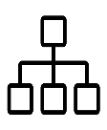

Identify

Intents

and

Entities



Building

a

Response

Fig. 1.1 How a Chatbot works

This figure shows how a chatbot works. Whenever a user asks any query, the bot will first analyze the request, then identifies intents and entities, builds a response and sends it back to the user. Now, intents mean intention of the query and entity means details of that query. For example, if a student wants to know the office hours of a faculty then the intent will be office hours and entity will be name of the faculty in this case.

AI-powered chatbots are motivated by the need of traditional websites to provide a chat facility where a bot is required to be able to chat with user and solve queries. When live agent can handle only two to three operations at a time, chatbots can operate without an upper limit which really scales up the operations. Also, if any school or business is receiving lots of queries, having a chatbot on a website takes off the load from support team. Having a chatbot clearly improves the response rate compared to human support team. In addition, since millennials prefer live chats over a phone call, they find a chatbot, which provide a highly interactive marketing platform, very attractive. Furthermore, a chatbot can automate the repetitive tasks. There can be some scenarios where a business or school receives same queries in a day for many times and support team must respond to each query repetitively. Lastly, the most important advantage of having a chatbot is that it is available 24/7. No matter what time it is, a user can get a query solved. All these advantages of a chatbot constitute the motivation to implement a College Enquiry Chatbot.

**1.1 SCOPE OF THE PROJECT**

The College Enquiry Chatbot is designed to help students to minimize the time required to solve the queries of an user and reduce the work load of the college’s office staff.

**1.2 OBJECTIVE OF THE PROJECT**

The most essential downside I found while utilizing the previously mentioned chatbots is absence of personality and conversational flow. As Storman [7] suggests, the CNN chatbot neglects to give sympathy and effortlessness. To be efficient, the chatbot must have the capacity to relate and associate itself with the user. For example, a discussion with the CNN chatbot is depicted in the article where at whatever point a user says anything aside from news or any current alternatives, it answers with the news comprising of those words and toward the end it says "Not sure I understand what you're looking for. Try again or pick one of the options below." and afterward it gives the choices as programmed. This implies, although it conveys the news proficiently, the CNN bot needs compassion.

Solution to this problem is described by Rahman et al. [8]. This study proposes that “there is a need to understand and consider the stability, scalability, and flexibility issues along with high level of intention of a human language”. Hence, for implementing a chatbot that handles complicated queries, the sentiment analysis is incorporated into College Enquiry Chatbot. Sentiment analysis aims to obtain writer’s feelings expressed in positive, negative or neutral comments. Based on sentiment analysis, the bot is trained to have empathy while answering to the user.

**CHAPTER 2**

**LITERATURE SURVEY**

A literature survey is a comprehensive summary of previous research on a topic. The literature review surveys scholarly articles, books, and other sources relevant to a particular area of research. It should give a theoretical base for the research and help you (the author) determine the nature of your research.

1. Harsh Pawar , Pranav Prabhu, Ajay Yadav, Vincent Mendonca , Joyce Lemos 6], a chatbot is designed by them using knowledge in database. The proposed system has Online Enquiry and Online Chatbot System. The development is done using various programming languages by creating a user friendly graphical interface to send and receive response. The main purpose is it uses SQL (Structured Query Language) for pattern matching which is been stored in program [6].
2. Nitesh Thakur, Akshay Hiwrale, Saurabh Selote, Abhijit Shinde and Prof. Namrata Mahakalkar [10], proposed an artificial chatbot using NLP (Natural Language Processing) which can be done in two ways the first via written text and the second is via verbal or voice communication. Written communication is much easier than the verbal communication. This paper introduces an interest in some emerging capabilities for evolving speed understanding and processing in human dialogue system [10].
3. In 2020, 3rd INTERNATIONAL CONFERENCE ON INNOVATIVE COMPUTING AND COMMUNICATION COMPARATIVE ANALYSIS OF CHATBOTS Shivang Verma, Lakshay Sahni, Moolchand Sharma, Department of Computer Science and Engineering, Maharaja Agrasen Institute of Technology, GGSIPU, Delhi, India, Department of Electrical and Electronics Engineering, Delhi Technological University, Delhi, India.
4. In March 2019, International Journal of Engineering Science and Computing - A Review on College Enquiry Chatbot By Jayesh Gangrade, Surinder Singh Surme, Sumant Somu, Shubham Raskonda, Poonam Gupta, Department of Computer G.H. Raisoni College of Engineering and Management, Pune, India. That project is an Andoid Application it's provide like grades of the student. That project has not response a unmatched keywords. Artificial intelligence will be used to answer the student's queries.[3] The answers will be give using the built in artificial intelligence algorithms.[3] Algorithm will be used to match the keywords from the knowledge base in some cases user may find out that the answer given to his/her query is not relevant. [3]
5. A Web Based College Enquiry Chatbot with Results By Sagar Pawar, Omkar Rane, Ojas Wankhade, Pradnya Mehta Department of Computer Engineering, MMCOE, Pune, India. That project is web based application has provide answer query is very efficiently. It also provide to the user to ask the tuition or private coaching enquiry to the classes, patient of the hospital to collect information like available Doctors.
6. In March 2018, Journal for Research -Chatbot for College Related Queries By Mr. Sathish Kumar .T, N. Vijay Kumar, R. R. Vinodh, T. Vivekananthan, U. Vinoth Kumar. In this project they are developed a web based application by using DataMining (Process of data- DWH; Level of data miningETL; Different level of Analysis- Artificial neural networks, Decision Trees, Nearest Neighbor Method) and Clustering. It provide user to chat any type of format. This system is trained by the dataset and also trained when come a new question query and answer them. This system is provide a College's activities such as date and time like annual day, sport day and other activities. They generate new responses from scratch.
7. Thomas N. T. and Amrita Vishwa designed an AIML and LSA based chatbot to provide the customer care service over the E- commerce websites. Their approach shows we can improve the chatbot ability by adding other models to it. In android operating system, we can implement the chatbot using the various approaches. One of the approaches is shown by Rushabh Jain and Burhanuddin Lokhandwala in their Android based Chat-Bot paper. Emanuela Haller and Traian Rebedea, "Designing a Chat-bot that Simulates and Historical Figure", IEEE Conference Publications, July 2013.
8. Maja Pantic, Reinier Zwitserdoot, and Robbert Jan Grootjans, Teaching Introductory Artificial Intelligence using A simple Agent Framework", IEEE Transactions on Education, Vol. 48, No. 3, August 2005. This paper describes a flexible method of teaching introductory artificial intelligence (AI) using a novel, Java-implemented, simple agent framework developed specifically for the purposes of this course. Although numerous agent frameworks have been proposed in the vast body of literature, none of these available frameworks proved to be simple enough to be used by first-year students of computer science. Hence, the authors set out to create a novel framework that would be suitable for the aims of the course, for the level of computing skills of the intended group of students, and for the size of this group of students.

**CHAPTER 3**

**SYSTEM ANALYSIS**

**3.1 EXISTING SYSTEM**

In Earlier there was no mode of online communication between users. In big or small institution communication between students become a challenge. There was requirement to record these communications and store the data for further evaluation. The idea is to automate the existing Simple Chat Room System and make the users to utilize the software so that their valuable information is stored digitally and can be retrieve for further management purposes. There was no online method of communicating to different users. There were many different interfaces available in the market but this method of using windows sockets to communicate between nodes would be fast and reliable.

* 1. **DISADVANTAGE OF EXISTING SYSTEM**
* Chatbots sound too Mechanical
* Chatbots can only handle basic questions
* Chatbots are difficult to create
* Chatbots require contant maintenance

**3.3 PROPOSED SYSTEM**

This Simple Chat Bot application will enable the user to chat with the users in the chat room. The server should be active. The users shall connect to this server at the predefined port number. To start using this tool, the user has to ask the query directly with this tool. Through the application shall allow the user to use the chat room. The user shall be able to connect to this server and can chat with other users. The user can view the chat room. The user can initiate the conversation through the chat window. For the communication to happen, both the users should have connected to the server. This application is developed using visual studio code. The windows sockets are used in the application for communication between client and server. They provide a robust way of communication between nodes. The user also can clear the chat transcript if required. It also provides an option to save the chat transcript.

* 1. **ADVANTAGES OF PROPOSED SYSTEM**
* Help students make better choices
* Simplify the Enrollment Process
* Share Relevant, Personalized Content
* Collect Student Data

**3.5 DESCRIPTION OF PROJECT**

A bot is a computer program that automates selected tasks by chatting with a user through a conversational interface. Highly advanced bots are powered by artificial intelligence, constantly learning from user requests and improving its knowledge base with each interaction. A chatbot script is an original document which outlines sequences of conversational messages based on user intention and selections.

**4.1 DATAFLOW DIAGRAM**

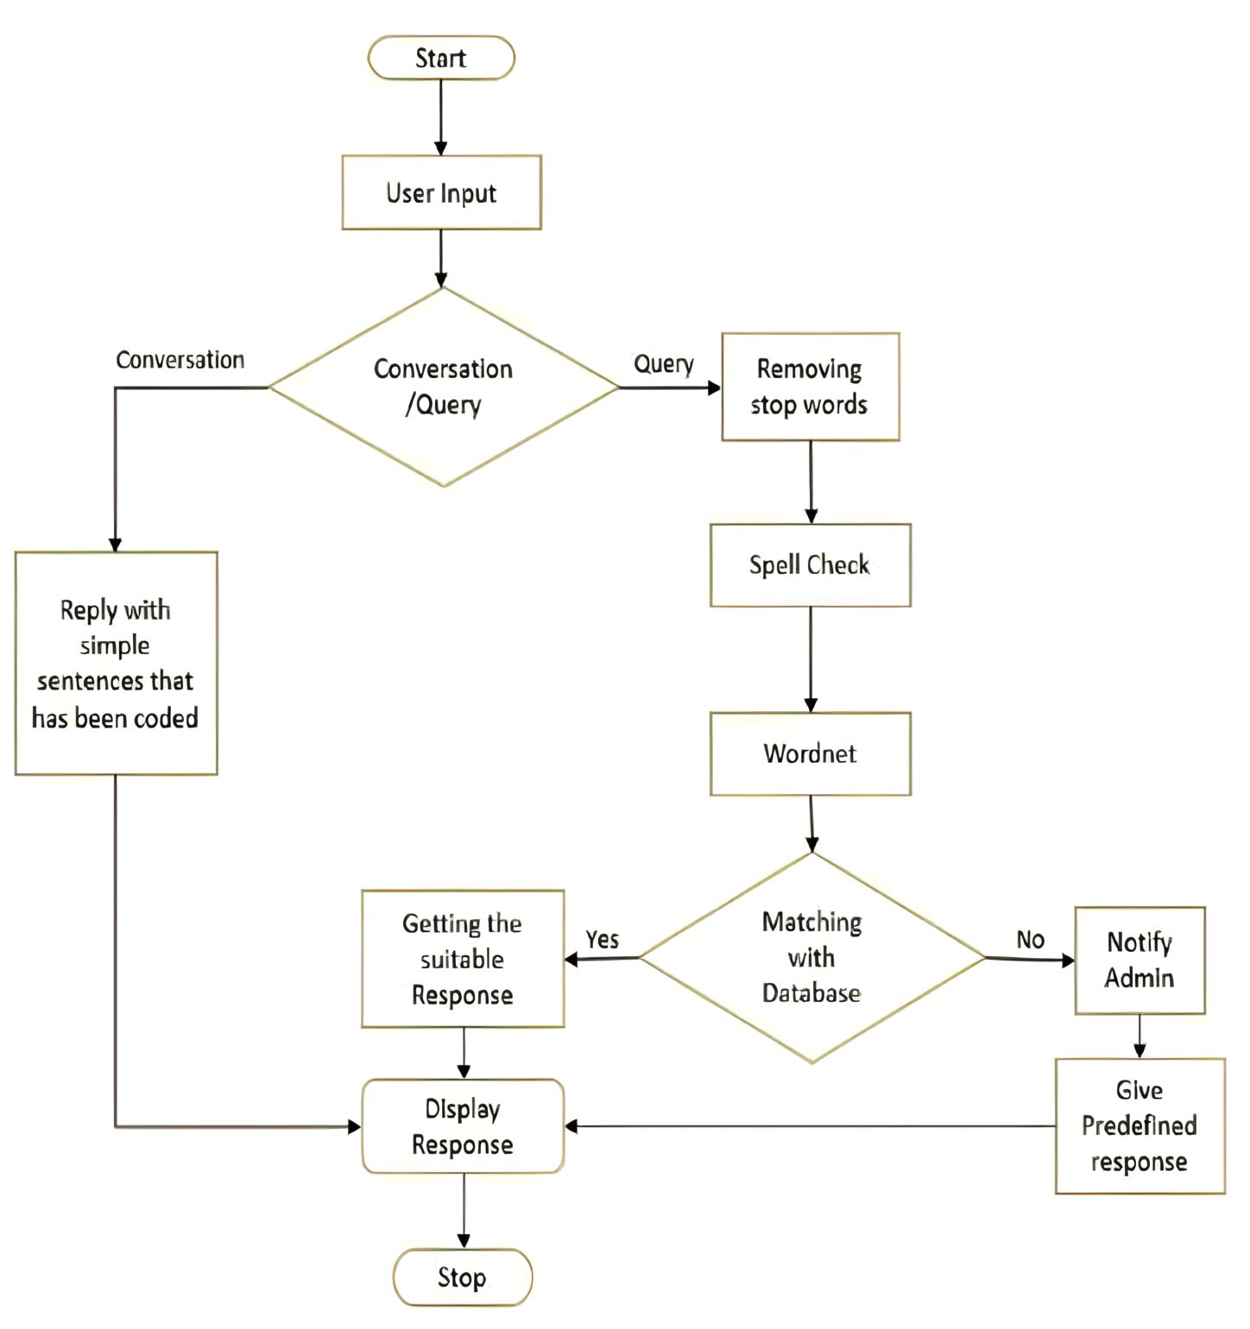

Fig. 4.1 Dataflow Diagram A Chatbot

**4.2 DATASET DESIGN INPUT**

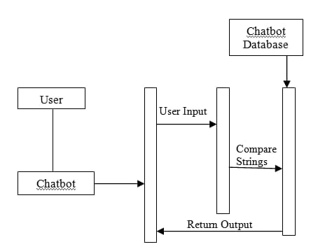

Fig. 4.2 Input Design

**CHAPTER 5**

**SYSTEM IMPLEMENTATION**

People like the quick response time and 24/7 access to chatbots, but at the end of the day, they want a human making the final sale. Below, we will implement you everything you need to know about chatbots, including how to get started with scripting your first bot. We’ll also show you how to create your first bot using [Hubspot’s Chatflows](https://www.hubspot.com/products/crm/chatbot-builder?utm_id=526319326465&utm_term=crm_hubspot%20chatbot_EN&utm_campaign=CRM_Portals_EN_NAM_NAM_Chatbot-Brand-NF_e_c_campaignid13428781323_agid120611214182_google&utm_source=google&utm_medium=paid&utm_content=&hsa_acc=9694350438&hsa_cam=13428781323&hsa_grp=120611214182&hsa_ad=526319326465&hsa_src=g&hsa_tgt=kwd-539522445597&hsa_kw=hubspot%20chatbot&hsa_mt=e&hsa_net=adwords&hsa_ver=3&gclid=CjwKCAiAnZCdBhBmEiwA8nDQxWLQTLQiZqHSZY5hTnbBY_8CxCpDiYdQw-dg9sq7mEGedbcNUcRcKhoC8xoQAvD_BwE&__hstc=60448754.b06695681b5c4dc4919def697a5ee3a3.1684567351559.1684577112245.1684731016639.3&__hssc=60448754.1.1684731016639&__hsfp=166988021), a free, intuitive tool that integrates seamlessly with Hubspot CRM.

**5.1 What is a chatbot?**

A bot is a computer program that automates selected tasks by chatting with a user through a conversational interface.

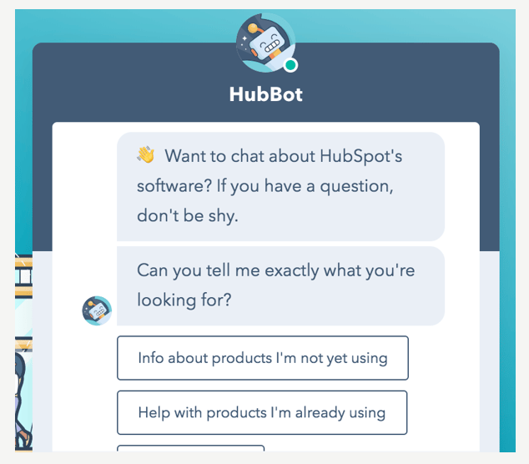

Fig. 5.1 Sample of a chatbot

### 5.2 How to Get Started with Chatbots

First, you’ll need to select a chatbot platform. With so many third-party plugins, you have a plethora of options to help you get started, here are a few we’re familiar with:

* [Hubspot free CRM](https://app.hubspot.com/signup/crm?hubs_campaign=partners-website-signup-link&partnerId=86417&utm_medium=acquisition-referral&__hstc=60448754.b06695681b5c4dc4919def697a5ee3a3.1684567351559.1684577112245.1684731016639.3&__hssc=60448754.1.1684731016639&__hsfp=166988021) and Chatbot builder
* Drift
* Chatfuel
* Pandorabots
* AgentBot
* ManyChat

In addition to the platform you’ll use to implement your bot, you’ll need a method to write, edit and share your bot scripts before implementation. Here are a few programs to consider:

* Microsoft Excel
* [Lucidchart](http://lucidchart.com/)
* Draw.IO
* Google Drawings
* Google Sheets
* [ArcTouch](https://arctouch.com/insights/design_templates/bot-design-ux-template/)

**5.3 What is a Chatbot Script?**

A chatbot script is an original document which outlines sequences of conversational messages based on user intention and selections.

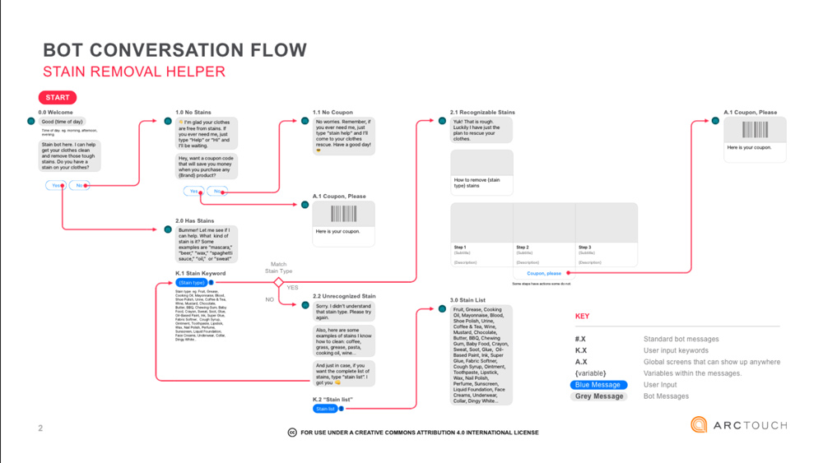

Fig. 5.2 Conversation flow diagram

* 1. **What To Consider Before You Start Writing**
* The script writing process starts with an understanding of the business process.
* Where is additional support required?
* What questions can a bot or artificial intelligence answer to support user experience?
* How can a bot filter MQLs towards SQLs?

**5.5 Chatbot execution starts with:**

* Finding the logical question and answer needs within the buyer journey.
* Crafting the narrative first.
* Building the bot second.

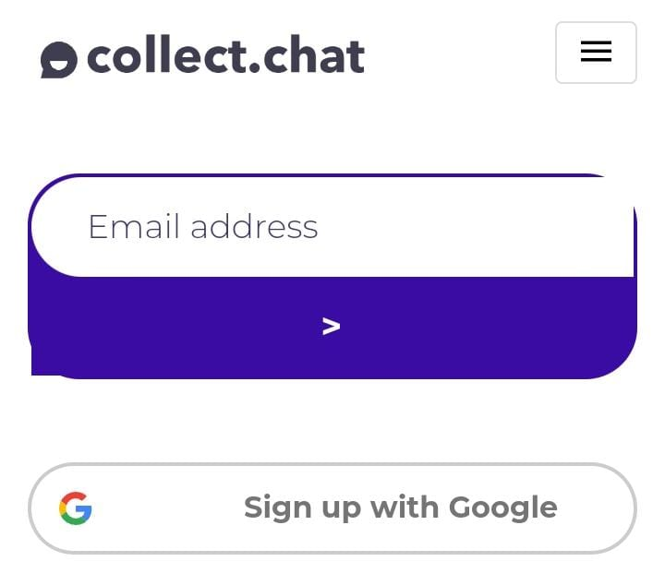

Fig. 5.3 Sigin in via Goggle

Crafting the narrative first is perhaps the most important chatbot consideration. Trying to fiddle in your bot platform adding and editing questions will just lead to frustration. Write the script for your buyer journey, leading MQLs to SQLs, and build the bot sequences second.

**5.6 How to Write Chatbot Scripts**

Here are our top tips on how to write your first chatbot script.

* **Remember your goals**

As you write chatbot dialogue, always keep in mind the goals of your chatbot -- what is the purpose it serves for user experience?

* **Be clear on the context**

Copywriters often follow this advice: imagine you are writing for a specific person, not for a vague target audience. This is where existing buyer personas can come into play: who are you talking to and more importantly, how do they want to talk to you?

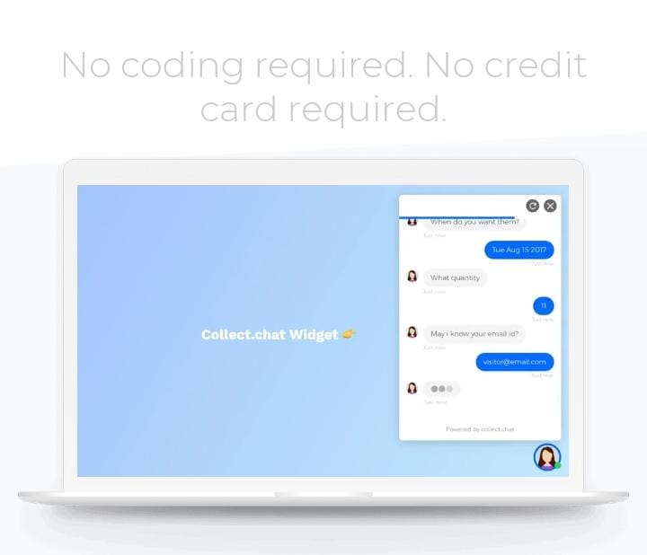

Fig. 5.4 Interface of the chatbot

* **Stay consistent**

Stay focused on your message, stick to your brand. Once you’ve created a unique personality for your bot, make sure you stay in character. This means you’ll need to remain consistent in your speaking style, vocabulary, and tone of voice.

* **Be concise**

Each message should not exceed three lines of text on mobile devices (60 to 90 characters). Much like any content these days, users don’t like to read long blocks of text and every additional line you add has the potential to tank engagement. Tip: break up your messages into a number of responses, mimicking a real conversation.

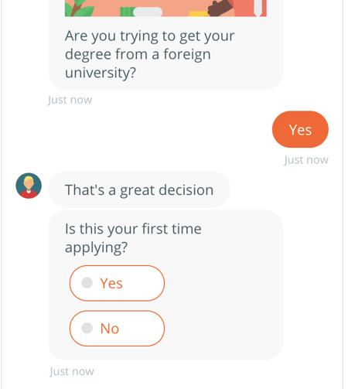

Fig. 5.5 Sample of collect.chat

* **Vary responses**

Consider adding a number of answers to a singular question in your script. Identical answers are sure to cause a poor user experience. Tip: this is only needed with AI bots, where users type in questions.

* **Finish strong**

After the conversation is over, take advantage of your visitors’ attention by adding in a personal touch. A simple “thank you” or wishing them well, will only add to their positive experience.

* **Sound natural**

Make every effort to talk like a real person, representing your brand voice, and how you’d imagine your brand might be personified. However, never pretend your bot is a real person.

* **Pace it out**

Intentionally pace how fast a user receives your messages to make the experience feel more natural. Adding a slight delay, like a real texting conversation, helps with engagement. Consider a 0.2 or 0.5-second delay between message

* **Chatbot works**

The chatbot qualifies and converts your visitors into customers by engaging them in a conversation rather than filling bring forms. No matters how many customers you have, collect.chat can take care of them . it will provide customers with a consistent experience each time they visit your website.

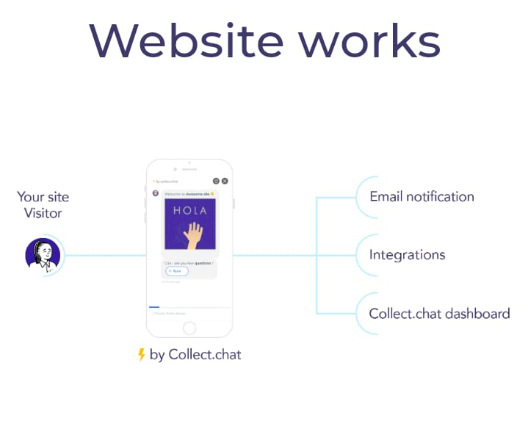

Fig. 5.6 Chatbot works in the website

* **Intergrating with other apps**

Use simple drag and drop tool to add questions and customise. Install or share the bot using HTML code, wordpress plugin or Chatbot page links. Get instant notifications via email, or collect.chat ddashboard and ntergrations. Connect it with hundred of apps in your workflow like salesforce, Mailchimp, slack without coding.

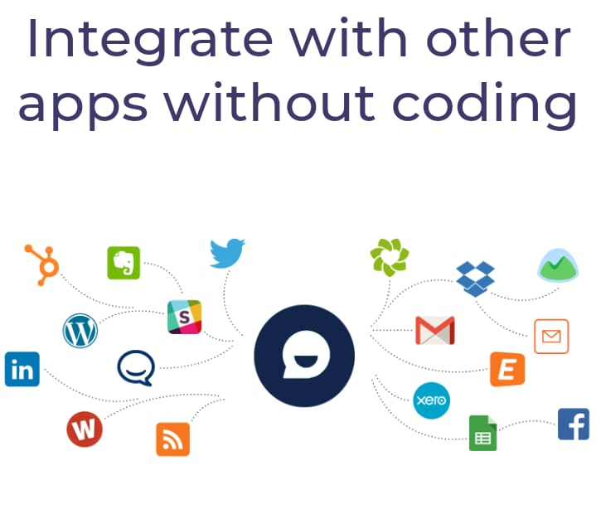

Fig. 5.7 Chatbot integration

**CHAPTER 6**

**SYSTEM REQUIREMENTS**

* 1. **SOFTWARE REQUIREMENTS**
* Operating system : Windows 10, 7,8 , Linux
* Language : HTML, Jvascript
* IDE : Visual Studio Code
  1. **HARDWARE REQUIREMENTS**
* Processor : 8 Octa Core Processor
* RAM : 32 GB
* Hard Disk Space : 50 GB
* NET Frame : 4.8

**SOURCE CODE**

Share the bot using HTML code

<!DOCTYPE html>

<html lang="en">

<head>

<title>Page Title</title>

<meta charset="UTF-8">

<meta name="viewport" content="width=device-width, initial-scale=1">

<style>

{

box-sizing: border-box;

}

body {

font-family: Arial, Helvetica, sans-serif;

margin: 0;

}

header {

padding: 80px;

text-align: center;

background:rgb(99, 96, 96);

color: white;

}

.header h1 {

font-size: 40px;

}

.navbar {

overflow: hidden;

background-color:white;

position: sticky;

position: -webkit-sticky;

top: 0;

}

.navbar a {

float: left;

display: block;

color: white;

text-align: center;

padding: 14px 20px;

text-decoration: none;

}

.navbar a.right {

float: right;

}

.navbar a:hover {

background-color: #ddd;

color: black;

}

.navbar a.active {

background-color: #666;

color: white;

}

.row {

display: -ms-flexbox; /* IE10 */

display: flex;

-ms-flex-wrap: wrap; /* IE10 */

flex-wrap: wrap;

}

.side {

-ms-flex: 30%; /* IE10 */

flex: 30%;

background-color: #f1f1f1;

padding: 20px;

}

.main {

-ms-flex: 70%; /* IE10 */

flex: 70%;

background-color: white;

padding: 20px;

}

.fakeimg {

background-color: #aaa;

width: 100%;

padding: 20px;

}

.footer {

padding: 20px;

text-align: center;

background: #ddd;

}

@media screen and (max-width: 700px) {

.row {

flex-direction: column;

}

}

@media screen and (max-width: 400px) {

.navbar a {

float: none;

width: 100%;

}

}

</style>

<script>(function(w, d) { w.CollectId = "646a04f80623c1a77168a5cf"; var h = d.head || d.getElementsByTagName("head")[0]; var s = d.createElement("script"); s.setAttribute("type", "text/javascript"); s.async=true; s.setAttribute("src", "https://collectcdn.com/launcher.js"); h.appendChild(s); })(window, document);</script>

</head>

<body>

<div class="header">

<h1>WELCOME TO MY WEBSITE</h1>

<p>A <b>CREATIVE</b> website created by me.</p>

</div>

<div class="navbar">

<a href="#" class="active">Home</a>

<a href="#" class="right">Link</a>

</div>

<div class="row">

<div class="side">

<h2>About Me</h2>

<h5>Photo of me:</h5>

<div class="fakeimg" style="height:200px;">Image</div>

<p>Some text about me</p>

<h3>More Text</h3>

<p>UDJSBDJ DHHJS</p>

<div class="fakeimg" style="height:60px;">Image</div><br>

<div class="fakeimg" style="height:60px;">Image</div><br>

<div class="fakeimg" style="height:60px;">Image</div>

</div>

<div class="main">

<h2>TITLE HEADING</h2>

<h5>Title description, Dec 7, 2017</h5>

<div class="fakeimg" style="height:200px;">Image</div>

<p>Some text..</p>

<p>Sunt in cit anim id est laborum consectetur adipi</p>

<br>

<h2>TITLE HEADING</h2>

<h5>Title description, Sep 2, 2017</h5>

<div class="fakeimg" style="height:200px;">Image</div>

<p>Some text..</p>

<p>Sunt in cs nostrud exercitation ullamco.</p>

</div>

</div>

<div class="footer">

<h2>Footer</h2>

</div>

</body>

</html>

Share the bot using Separate Web Page

https://chatbot.page/CmLuzE

Share the bot using **HTML code**

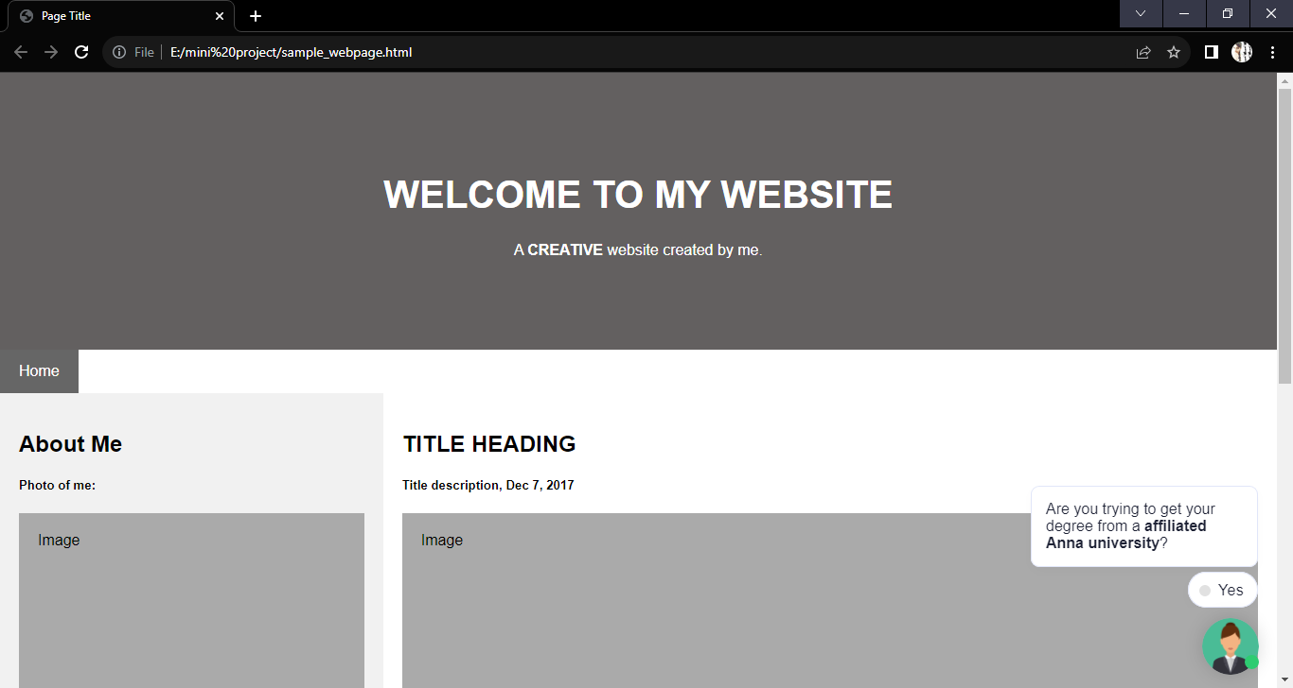

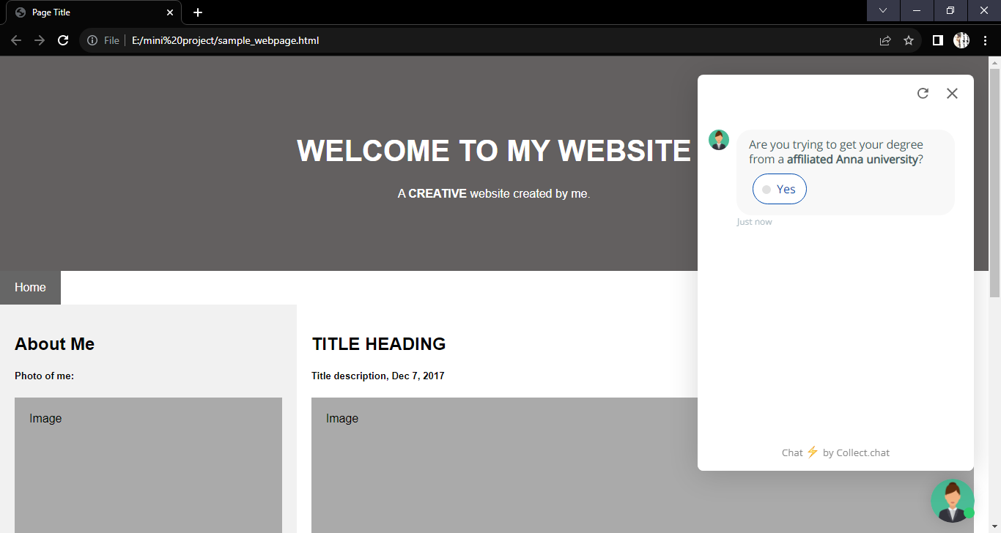

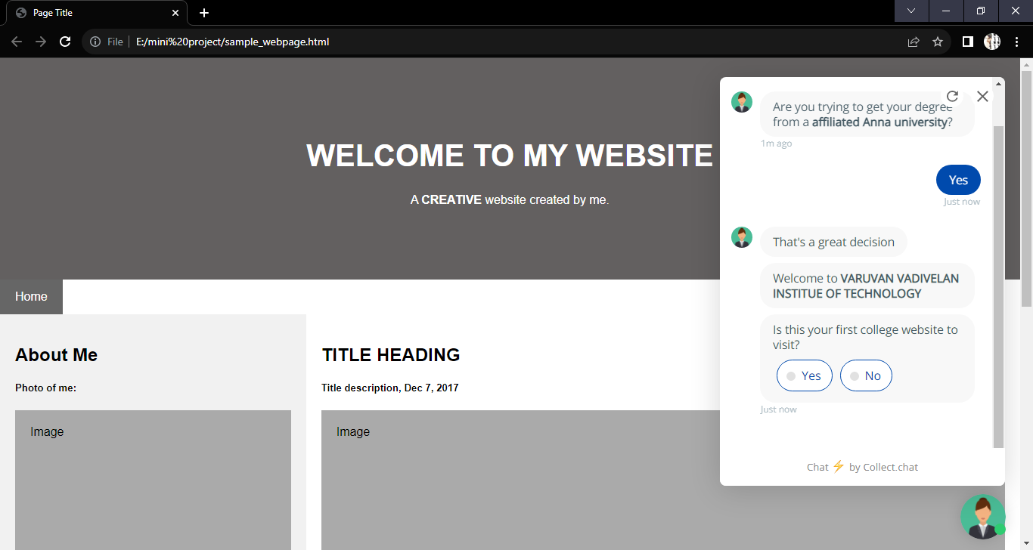

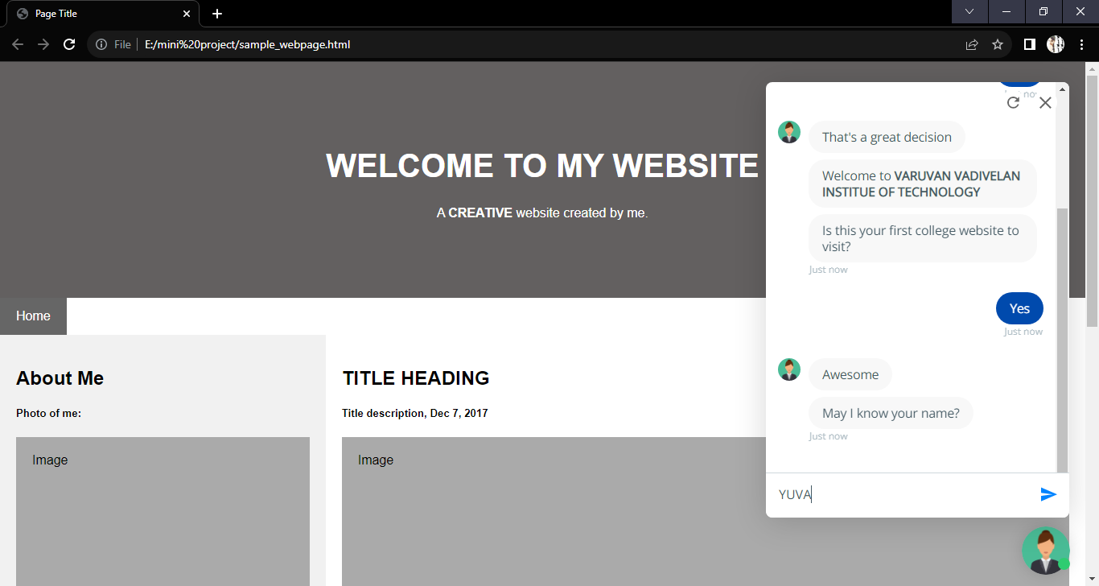

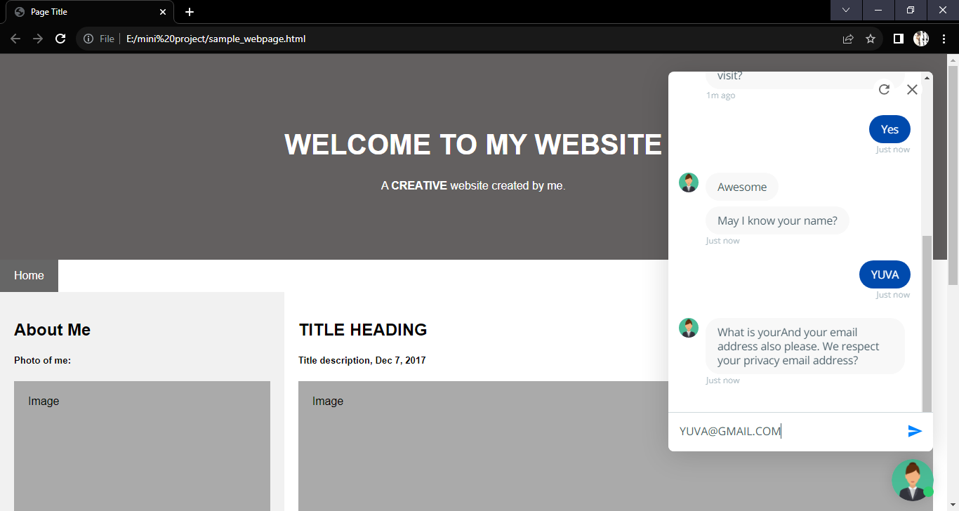

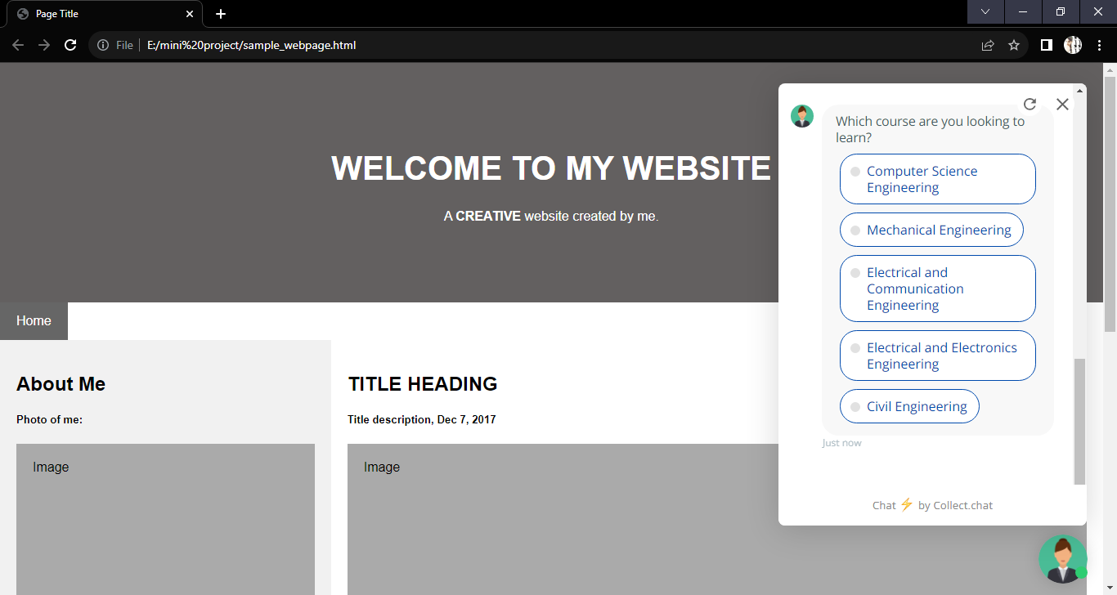

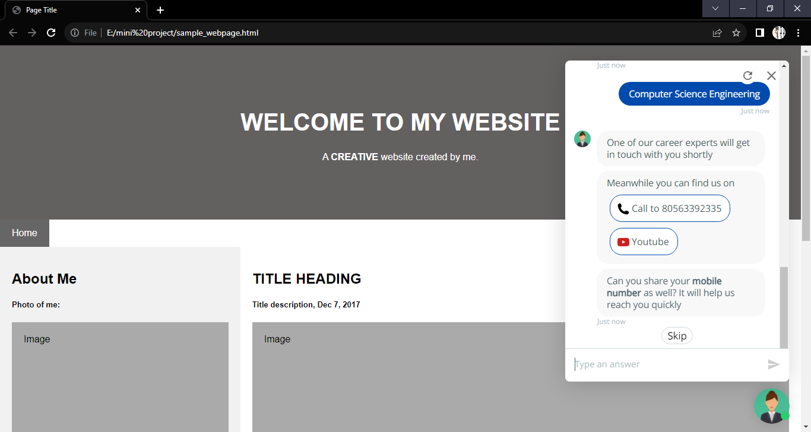

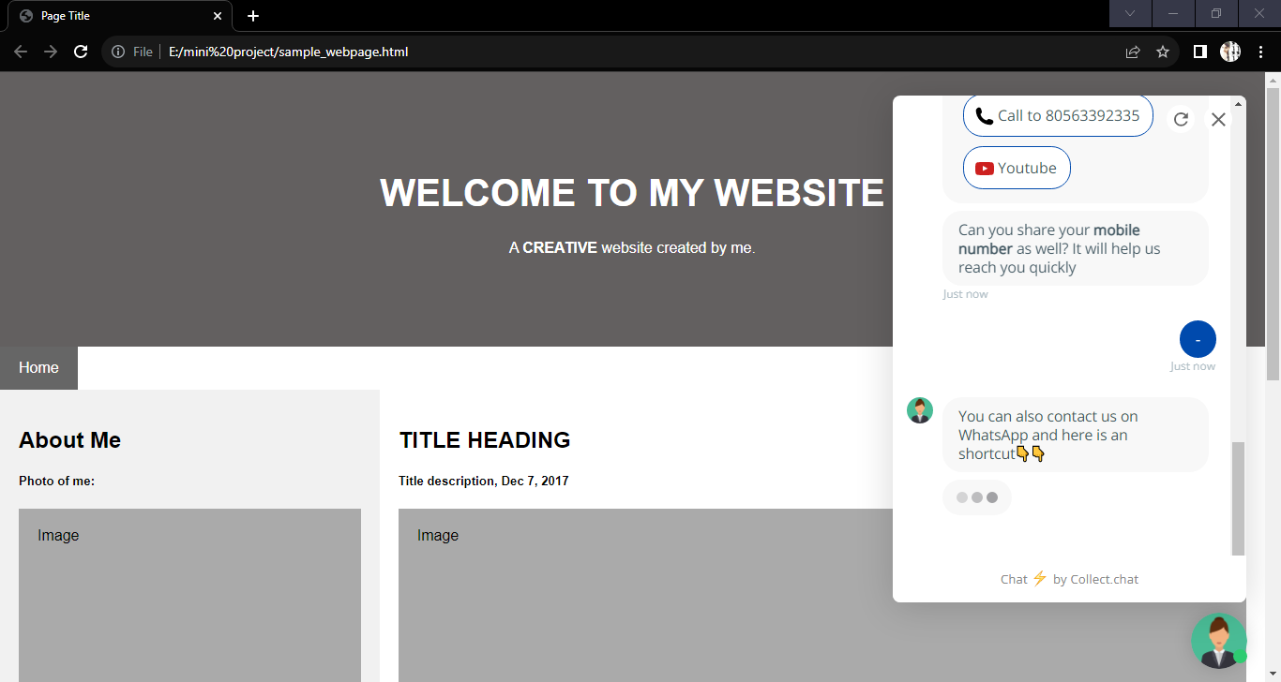

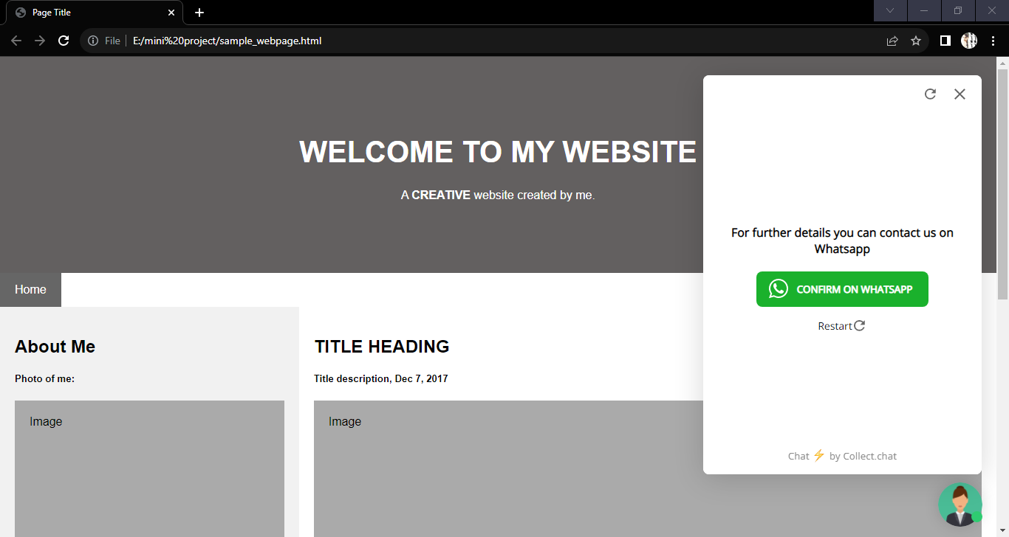

Share the bot using **Separate Web Page**

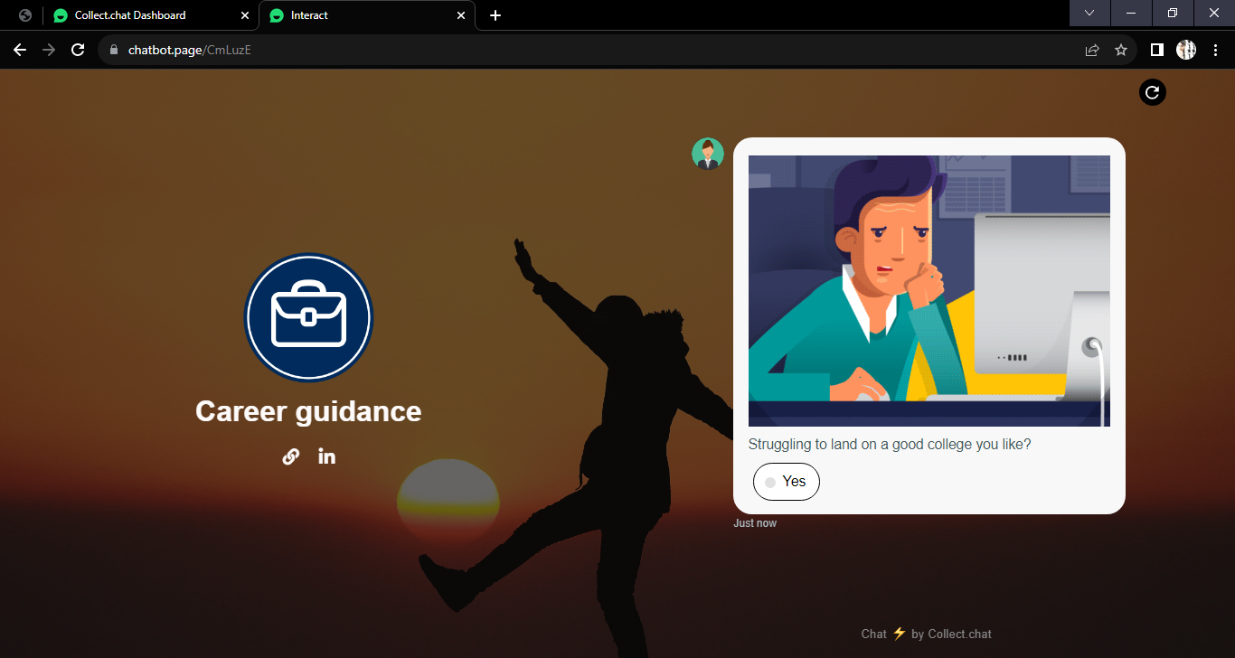

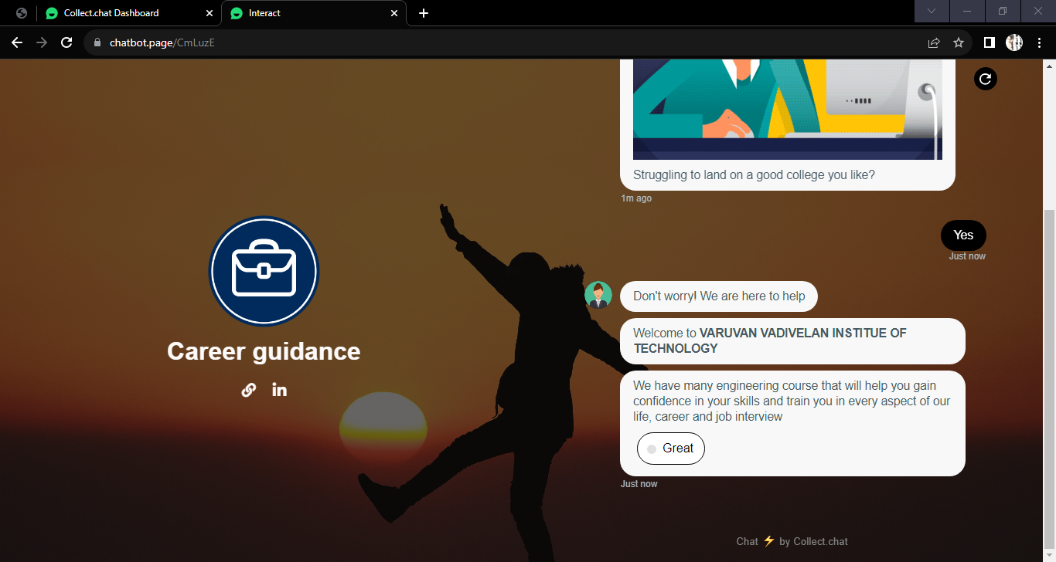

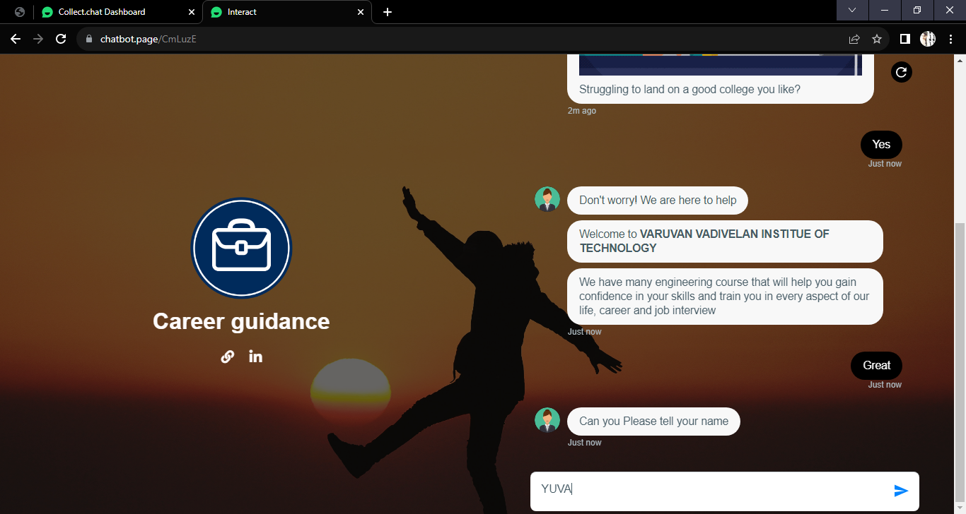

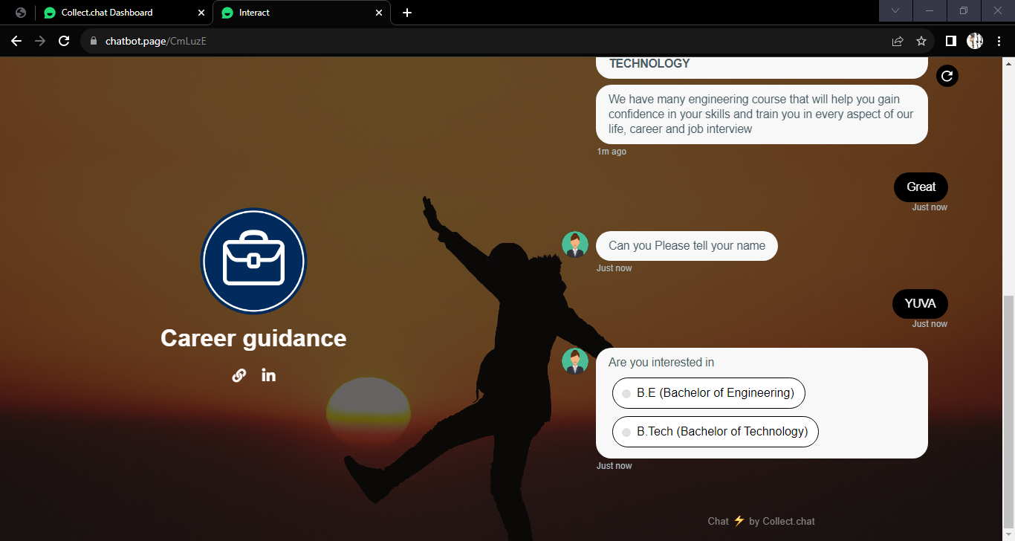

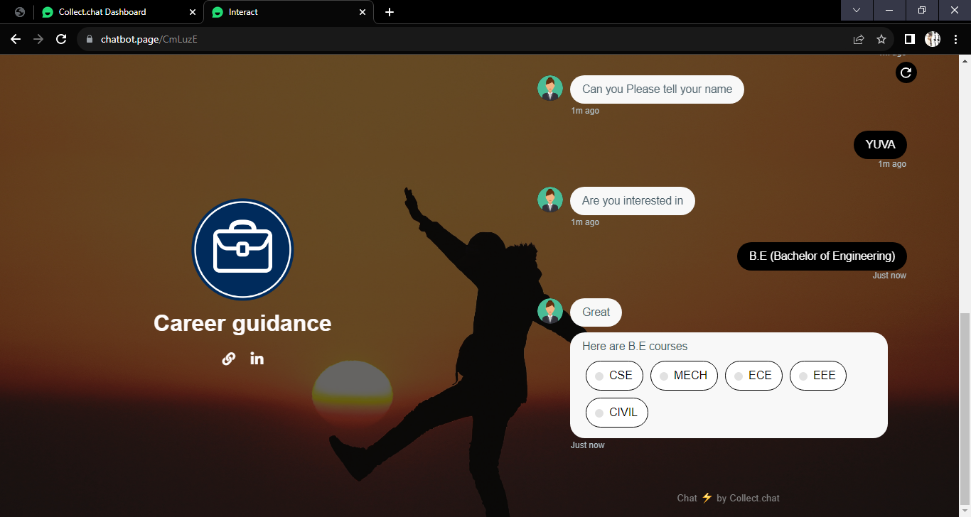

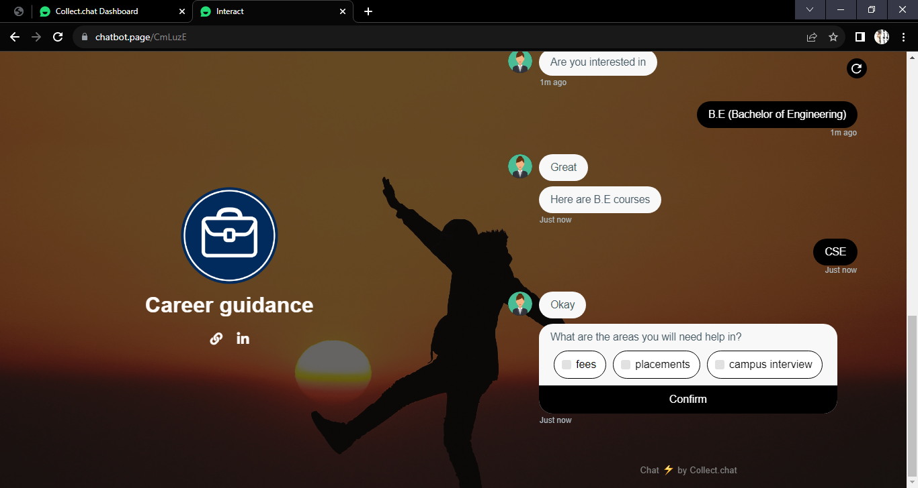

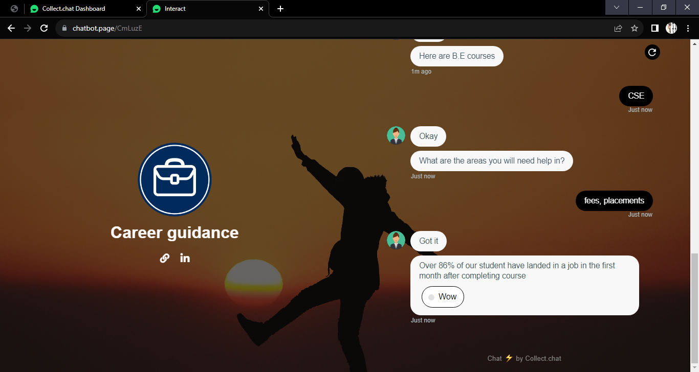

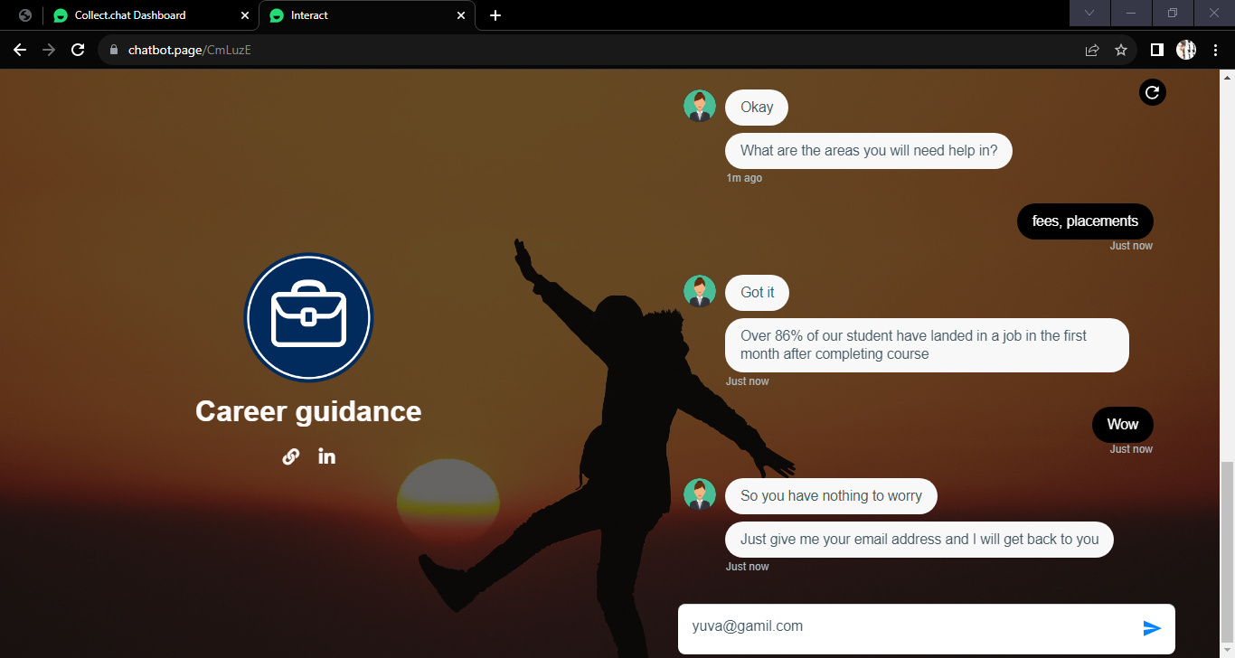

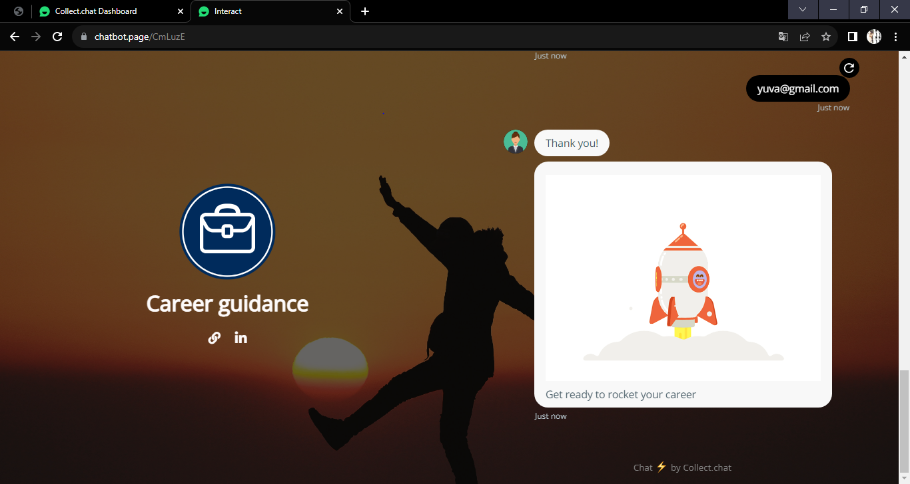

### CHAPTER 9

### CONCLUSION AND FUTURE WORK

To conclude, College Enquiry Chatbot is helpful in guiding students with correct and most up to date sources of information. It is advantageous for international applicants for queries such as fee payment and academic matters. Students can get the information at their fingertips rather than visiting college office. It improves efficiency by taking over tasks for which humans are not essential.

Sentiment analysis implemented in College Enquiry Chatbotcorrectly recognizes the user’s query such as positive, negative, and neutral by storing all the conversations in the database. However, the system was partially successful in adding empathy since scope of these queries is vast and the system requires more rigorous data to handle all the questions which are out of script. Nevertheless, active learning helps to improve the bot performance for handling off-script queries.

To improve the current functionalities of College Enquiry Chatbot, in the future, the scope of the chatbot can be increased by inserting data for all the departments, training the bot with varied data, testing it on live website, and based on that feedback inserting more training data to the bot. Some of the new features which can be added to the bot are 1) speech recognition feature through which students can ask their queries verbally and get the answers from the bot, 2) integration with multiple channels such as phone call, SMS, and various social media platforms like Skype, Facebook and Twitter, 3) handling context aware and interactive queries in which bot will be aware of the context of an ongoing conversation with a student.

**REFERENCES**

1. "Chatbot", en.wikipedia.org, 2010. [Online]. Available: [https://en.wikipedia.org/wiki/Chatbot.](https://en.wikipedia.org/wiki/Chatbot) [Accessed Jul. 10, 2018].
2. "Chatbot: What is Chatbot? Why are Chatbots Important? -", Expertsystem.com, 2018. [Online]. Available: [https://www.expertsystem.com/chatbot/.](https://www.expertsystem.com/chatbot/) [Accessed Sep. 11, 2018].
3. "Amazon.com: Online Shopping for Electronics, Apparel, Computers, Books, DVDs & more", Amazon.com, 2017. [Online]. Available: [https://www.amazon.com/.](https://www.amazon.com/) [Accessed Sep. 12, 2018].
4. "Amazon Alexa - Build for Amazon Echo Devices", Developer.amazon.com, 2017. [Online]. Available: [https://developer.amazon.com/alexa.](https://developer.amazon.com/alexa) [Accessed Sep. 12, 2018].
5. Official website of an collect.chat, here we can create and integrate <https://dashboard.collect.chat/workspace/6416f0614c85d38d645810cb>
6. A. Storman, "5 Chatbot Challenges and How to Overcome Them", Chatbots Magazine, 2016. [Online]. Available: [https://chatbotsmagazine.com/5-chatbotchallenges-and-how-to-overcome-them-caccc3a26d7c.](https://chatbotsmagazine.com/5-chatbot-challenges-and-how-to-overcome-them-caccc3a26d7c) [Accessed Sep. 11, 2018].
7. A. M. Rahman, A. A. Mamun and A. Islam, "Programming challenges of chatbot: Current and future prospective," *in 2017 IEEE Region 10 Humanitarian Technology Conference (R10-HTC), Dhaka, 2017*.
8. "Problems with Chatbots Today - Attunix", Attunix, 2018. [Online]. Available: [https://attunix.com/problems-chatbots-today/.](https://attunix.com/problems-chatbots-today/) [Accessed Sep. 11, 2018].